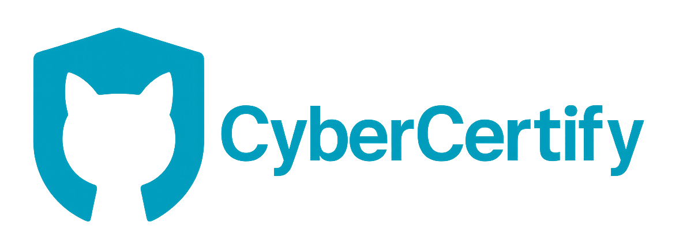
KV6014 – Week 3 Project Lead Deliverable
Project Context
Module: KV6014 – Group Computing Project
Challenge Chosen: Cyber Security Engagement
Route: Design-Led – focusing on user experience, interaction design, and novel engagement methods.
Role: Project Lead – responsible for the agile plan, story map, team coordination, and user-oriented vision.
Team Composition: Developer · Designer(s) · Cybersecurity Consultant

Core Concept
CyberCertify is a gamified cybersecurity awareness training website designed to improve digital literacy and online trust.
Features
- Issues certifications upon course completion
- Provides verification badges for businesses to improve user trust
- Integrates 2FA and ID linking for authentication and credibility
- Uses playful learning and interactive challenges to keep users engaged
This approach blends education, authentication, and trust-building into a single, engaging platform.

Project Overview / Epic
For: Individuals and businesses seeking to improve cybersecurity awareness and promote trust in digital environments.
Who: Struggle to identify secure websites and lack awareness of phishing, data leaks, and identity theft.
Our: Design-led web platform
Is a: Gamified cybersecurity awareness and certification system
That: Provides interactive, scenario-based training that rewards users with verifiable certifications while helping businesses display their security compliance through trust badges and 2FA identity verification.
This solution directly addresses the Cyber Security Engagement challenge by merging education, verification, and trust-building in one user-friendly system.

Agile Plan Overview
Development is structured using Agile methodology — two-week sprints focusing first on user experience (UX) and design iteration.
Sprint | Focus | Objectives
1 (Weeks 1–2) | Concept & Problem Framing | Define target users, identify learner vs. business needs, brainstorm gamification strategies, and analyze existing solutions.
2 (Weeks 3–4) | UX Research & Wireframes | Conduct design iterations in Figma, map user journeys, and establish certification & 2FA user flow.
3 (Weeks 5–6) | Prototype & Gamified Interactions | Build interactive modules, scoring systems, and test engagement levels.
4 (Weeks 7–8) | Verification & Security Layer | Develop business verification portal and test ID-linked 2FA process.
5 (Weeks 9–10) | Evaluation & Refinement | Perform usability testing, measure engagement, refine UX for final demo.
This structure ensures iterative progress while maintaining strong design and security checkpoints.

User Stories
- As a learner, I want to complete interactive cybersecurity challenges so I can earn a verified certificate.
- As a user, I want a progress-tracking dashboard so I can visualize how close I am to certification.
- As a business owner, I want to verify staff training completion to ensure compliance and credibility.
- As a business, I want to display an official trust badge to show secure data handling.
- As a security-conscious user, I want my certification tied to a verified ID with 2FA for authenticity.
- As a returning user, I want to access my progress and certifications for seamless learning.
- As a system admin, I want to track engagement and success metrics to measure impact.
- As a visitor, I want to verify a business’s legitimacy via the directory for trust assurance.
- As a designer, I want consistent UI elements to ensure intuitive navigation.
- As a developer, I want scalable backend architecture to support multiple organizations.

Story Mapping
Stage | Linked Stories | Outcome
1. Discovery | 1, 2, 5 | User registers, authenticates via 2FA, and explores gamified learning paths.
2. Learning Engagement | 1, 2, 9 | User completes mini-games and quizzes with progress indicators.
3. Certification | 1, 3, 4 | System issues verified certificates and public records of achievement.
4. Business Verification | 3, 4, 8 | Businesses apply for trust badges; users can verify them on the platform.
5. Maintenance & Analytics | 7, 9, 10 | Admins monitor engagement and update UX for long-term reliability.

Design-Led Justification
Following the Design-Led Route, the focus is on interaction quality and user experience before technical implementation.
Key Design Goals:
- Figma Wireframes – visualize onboarding and certification flows.
- Gamified Progress – XP points, levels, and achievement badges for engagement.
- Trust Badge Design – embed verification seals into business websites.
- Dual User Flow – separate yet connected experiences for individuals and businesses.
- Feedback Loops – data-driven prompts to encourage continued learning.
The system priorities engagement, clarity, and trust — ensuring the educational process feels interactive, rewarding, and credible.

Leadership Actions & Reflection
Week 3 Focus: Strengthening direction, collaboration, and scope clarity.
Key Actions
- Aligned all roles (developer, designer, cybersecurity consultant) with a unified design vision.
- Clarified deliverables and connected each user story to the main project epic.
- Set up a Trello agile board with deadlines and sprint dependencies.
- Worked closely with designers to ensure accessibility, clarity, and flow.
- Collaborated on secure login, data encryption, and privacy-by-design (2FA).
- Led stand-ups and progress tracking for transparency.
- Balanced gamification with professional tone to maintain dual appeal.
Reflection
“This week, my role was to make cybersecurity engaging without losing credibility.
I helped transform our abstract challenge into a structured, testable concept ready for development.”

Next Steps (Week 4)
- Finalize low-fidelity prototype in Figma for usability testing.
- Begin backend planning for certifications and directory management.
- Develop mock API for 2FA and user identity linking.
- Conduct internal UX review to refine interaction flow.
- Prepare sprint review presentation for Week 4 supervision.

Future Improvements (Optional Extensions)
- Add Risk Management Table linking to cybersecurity consultant outputs.
- Include Task Ownership Chart to show individual contributions.
- Create Design Style Guide for consistency across future iterations.

“CyberCertify turns cybersecurity awareness from a checkbox into an experience — where learning, trust, and design intersect.”

